4 a) Installation of Citrix XenServer 4 b) Live Migration of Virtual Machines using Xen Center
Aim:
To install and configure Citrix XenServer for virtualization of multiple operating systems , use Xen Center for graphical management of virtual machines and perform live migration of VMs between physical hosts without downtime.
Xen
Xen is a Type 1 (bare-metal) hypervisor that enables the execution of multiple virtual machines (VMs) on a single physical machine by abstracting the hardware. It supports both paravirtualization and hardware-assisted full virtualization (via Intel VT or AMD-V).
Virtualization Type: Para or Full?
Feature | Xen
Supports | Both Paravirtualization (PV) and Hardware-assisted Full Virtualization (HVM)
Default Mode | Originally designed for Paravirtualization (efficient, faster)
With Hardware Assist | Uses HVM mode for OSes like Windows (needs CPU virtualization support)

Xen Type 1 vs Type 2 Hypervisors
Feature | Type 1 (Xen) | Type 2
Runs on | Bare metal (hardware directly) | Runs on host OS
Examples | Xen, VMware ESXi, Microsoft Hyper-V | VirtualBox, VMware Workstation
Performance | High performance, low overhead | Slightly lower performance
Security | More secure (minimal layers) | Depends on host OS security

Equivalent Hypervisors to Xen
Hypervisor | Type | Notes
KVM | Type 1 (in Linux kernel) | Integrated with Linux, uses hardware virtualization
VMware ESXi | Type 1 | Enterprise-grade, GUI support
Microsoft Hyper-V | Type 1 | Windows-based hypervisor
VirtualBox | Type 2 | Desktop virtualization

Requirements for Live Migration in Xen
- Shared Storage (e.g., NFS, iSCSI, SAN): Both hosts must access the same virtual disk.
- Same CPU family: Compatible CPU features between source and destination.
- Network Connectivity: Low-latency, high-speed network between hosts.
- Xen-compatible tools: xm, xl, or XenAPI-based management like XenCenter.
- Proper Configuration: Dom0 should have migration tools enabled, with firewall ports open.

XenServer vs XenCenter
Feature | XenServer | XenCenter
Definition | Commercial distribution of Xen hypervisor | GUI-based management tool for XenServer
Runs on | Physical Server (bare-metal) | Windows desktop (client-side software)
Function | Creates and runs VMs | Manages, monitors, and controls XenServer
Open Source? | XenServer is partly open-source (Citrix) | XenCenter is free but not open-source

a)
Citrix XenServer is a virtualization platform based on the open-source Xen Hypervisor. It enables efficient creation, management, and execution of multiple virtual machines (VMs) on a single physical host.
Installation Steps:
- Download ISO:
  - Get the official XenServer ISO from Citrix website.
- Create Bootable Media:
  - Use tools like Rufus or Ventoy to create a bootable USB with XenServer ISO.
- BIOS Settings:
  - Enable VT-x / AMD-V (hardware virtualization) and set USB as first boot device.
- Boot and Install:
  - Insert the USB and boot the server.
  - Follow the on-screen instructions:
    - Select installation drive (e.g., local disk).
    - Configure network settings (static IP recommended).
    - Set root password.
    - Choose to install XenServer tools
- Complete Installation:
  - Reboot system after installation.
  - XenServer boots with a console UI showing IP address and system info.

4b) Live Migration of Virtual Machines using XenCenter
Live Migration refers to moving a running virtual machine from one physical host to another without shutting it down, using XenCenter’s GUI.

Steps 1:
Add the new server by clicking the server in the xencenter and server-> Add

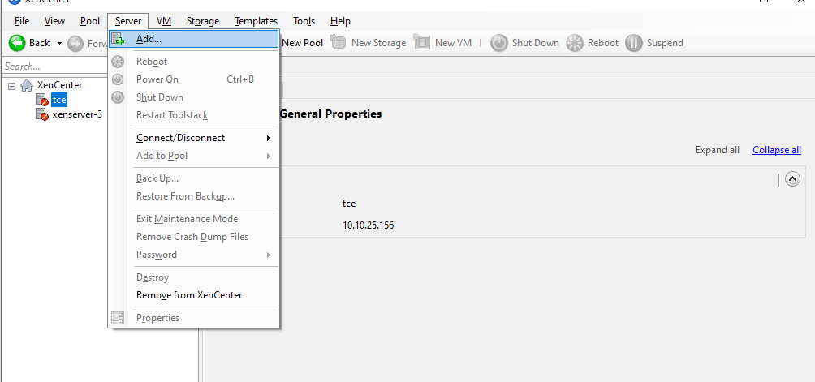

Steps 2:
Add the xenserver 1 by entering the Server , Username and password and click add.
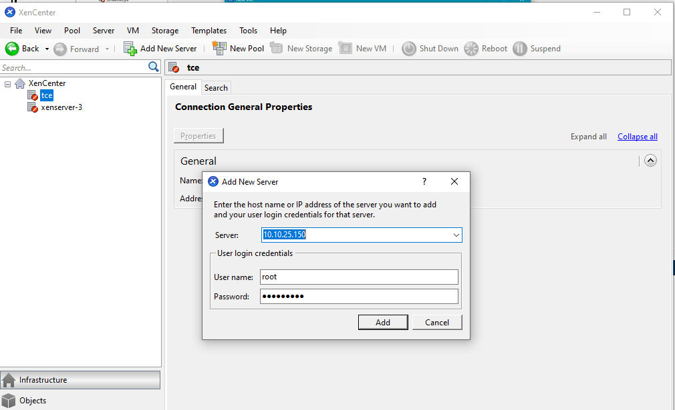
Steps 3:
Next add the vm of yours by clicking the xenserver 1 (right click) and add click new vm
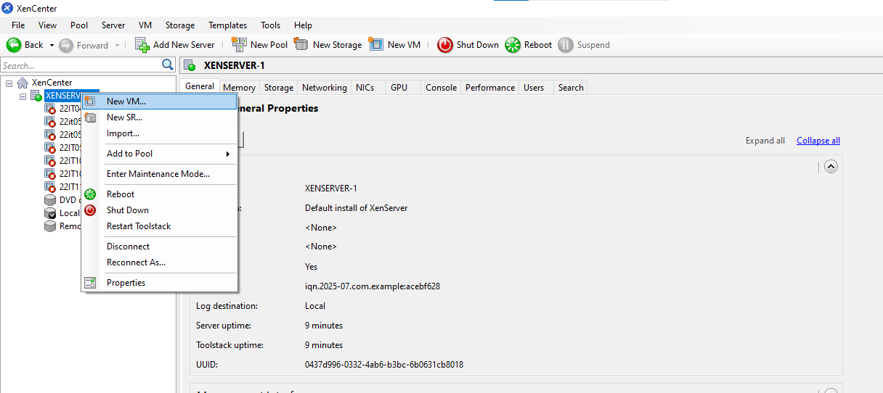

Steps 4:
Click the template example citric or ubunttu os or cent os(os which you have).
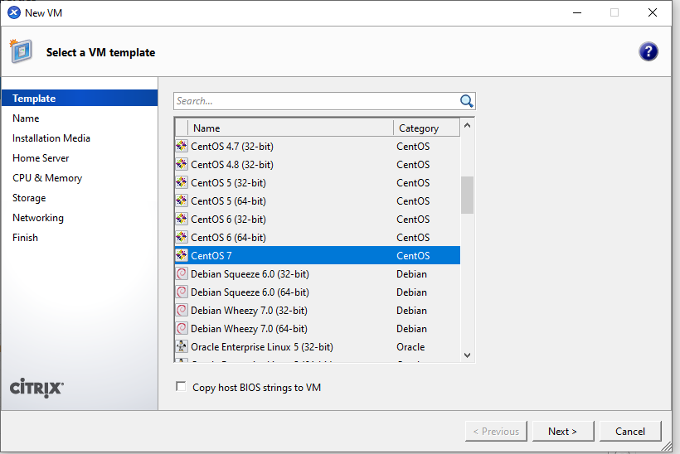
Steps 5: Give the name for your Vm and click next.
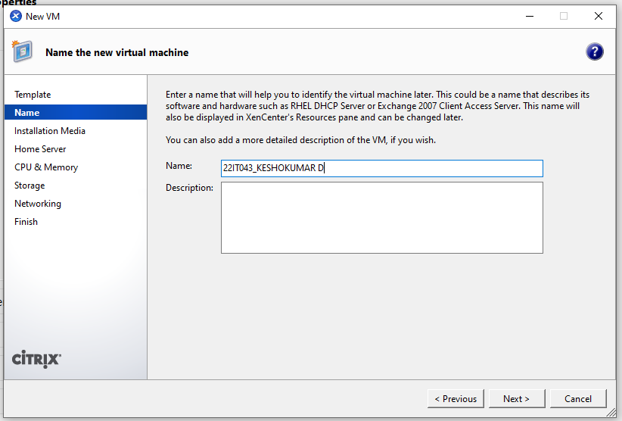
Steps 6: Select the iso file inside and click the next
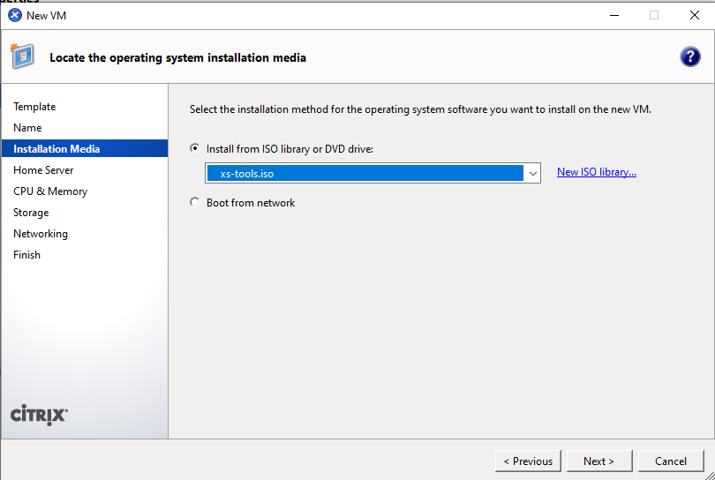
Steps 7:
Finally click the create now option then your vm has been created successfully.
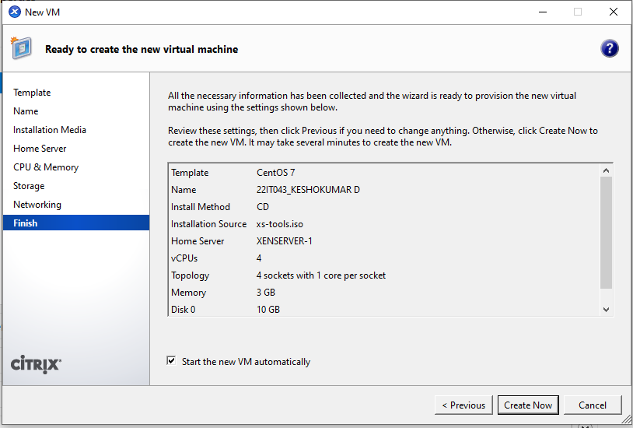
Steps 8: Create a xenserver 2 same procedure followed in first xenserver1 and click the xenserver 1.
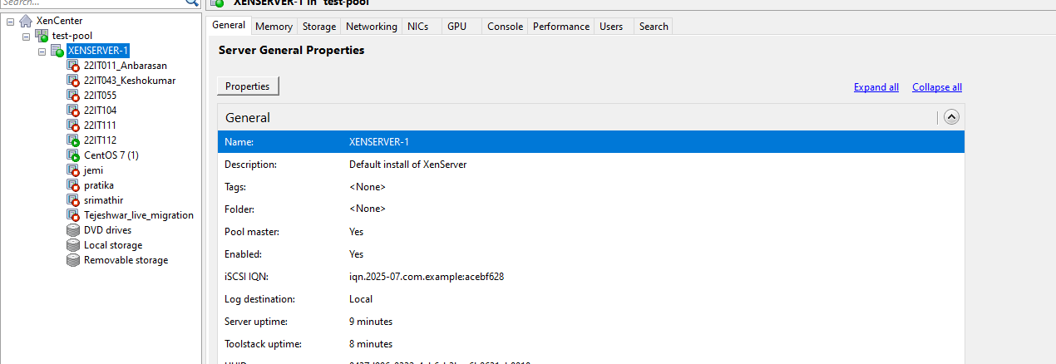
Steps 9:
Right click the vm and select the move vm option from the following
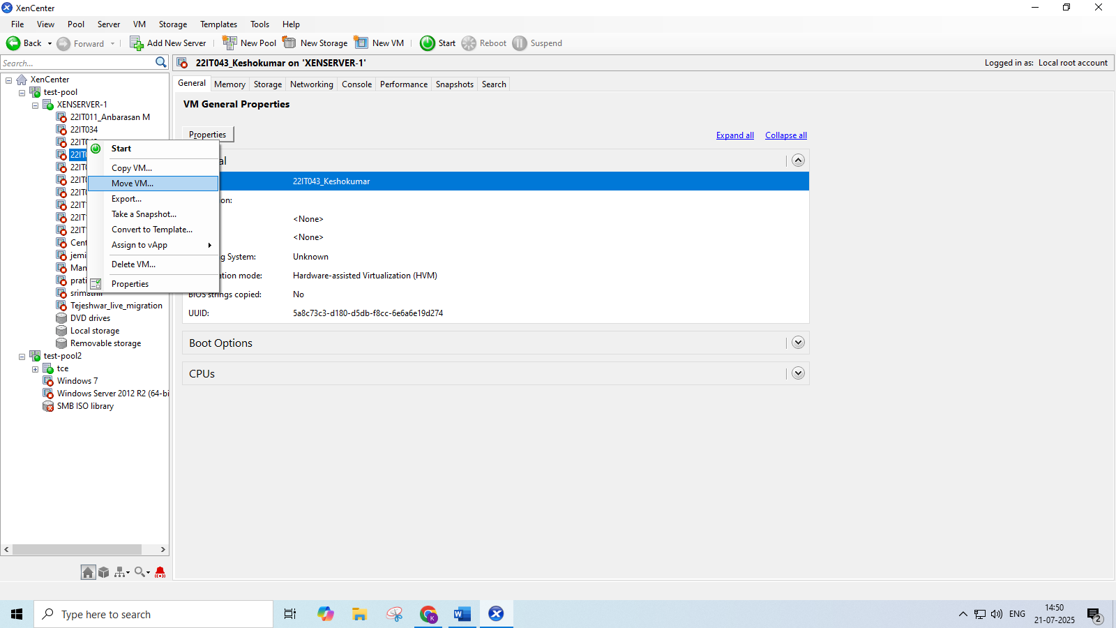
Steps 10: Select the xenserver 2 from the following list
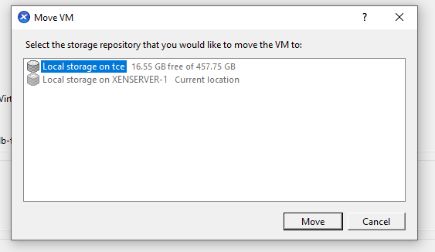
Steps 11:
Now see the Vm in the second server tce and the live migration has been executed successfully.

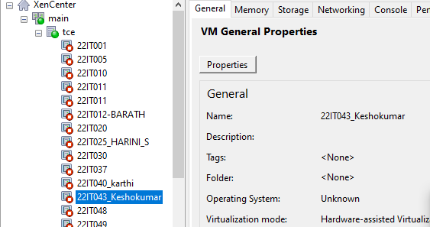

RESULT:
Successfully executed the setup of XenServer and XenCenter; live migration was performed and output verified with zero downtime during VM transfer.

